# **TensorFlow Playground Report**

1. **A brief introduction to neural networks and their components:**

**Neural network:** A neural network is like a computer version of how our brains work. It's made up of these little units called neurons, which are kind of like brain cells. These neurons are grouped together in layers, just like our brain has different layers of processing.

**Neurons (Nodes):** An artificial neuron mimics the function of a biological neuron. Each artificial neuron receives inputs, each with an associated weight. These inputs are multiplied by their corresponding weights and summed together. The neuron also has a bias, which is added to this sum.

**Layers:** First layer of each neuron represents a feature in the input data. The hidden layers are the middle layers between the input and output layers. They do all the heavy lifting, processing and transforming the data. How many hidden layers you have and how many neurons are in each layer determine the overall design (or architecture) of your network—basically, how deep and wide it is.

**Activation function -**

There are four types of activation function –

1. ReLU (Rectified Linear Unit)
2. Tanh
3. Sigmoid
4. Softmax

Activation functions are crucial in neural networks as they introduce non-linearity, allowing the network to learn complex patterns. Activation function is a mathematical function applied to the output of a neuron in a neural network layer. Here's a comparison of some common activation functions:

**Comparison Summary**

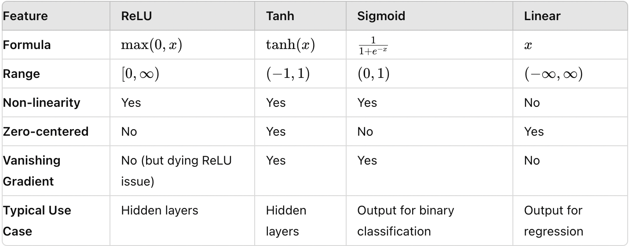

Each activation function has its specific use cases, advantages, and disadvantages. The choice of activation function can significantly impact the performance and efficiency of a neural network.

**1. ReLU (Rectified Linear Unit)**

|  |  |
| --- | --- |
| **Advantage** | **Disadvantage** |
| Computationally efficient (simple threshold at zero) | "Dying ReLU" problem, where neurons get stuck in the negative side and stop learning. |
| Helps mitigate the vanishing gradient problem | Not zero-centered |

**2. Tanh (Hyperbolic Tangent)**

|  |  |
| --- | --- |
| **Advantage** | **Disadvantage** |
| Zero-centered | Can suffer from the vanishing gradient problem, especially for deep networks, which can slow  down or halt training. |
| Good for hidden layers in neural networks as it can push the mean of the activations closer to zero. |  |

**3. Sigmoid**

|  |  |
| --- | --- |
| **Advantage** | **Disadvantage** |
| Useful for models where output needs to be interpreted as a probability. | Can suffer from the vanishing gradient problem |
|  | Not zero-centered |

**4. Linear (Identity)**

|  |  |
| --- | --- |
| **Advantage** | **Disadvantage** |
| Simple and can be useful in the output layer for regression problems. | No ability to learn complex patterns since it's a linear function |

1. **A description of each task, along with screenshots or visualizations:**

**Task 1: Activation Functions:**

Activation functions and their purposes have been explained in part 1 above. The first experiment is with creating a neural network with one hidden layer with ReLU activation functions.

In the below picture (1), we can see that the learning rate is 0.03 and activation function is ReLU with 1 hidden layer and 3 neurons. Here we can see that training the model is successful. The test loss shown over here is at 0.014 and the training loss is at 0.002, which has very slight difference between the training and test loss. The training model starts with equally weighted X1 (vertical) and X2 (horizontal) neurons and then it will distribute the weight into the three neurons in the hidden layer. If the neurons are weighted heavily, it will show you a thicker link connected with the output. And when we combine the results of the neurons, we get the result in the output box as a shading of orange and blue colors. Orange shows negative values while blue shows positive values.

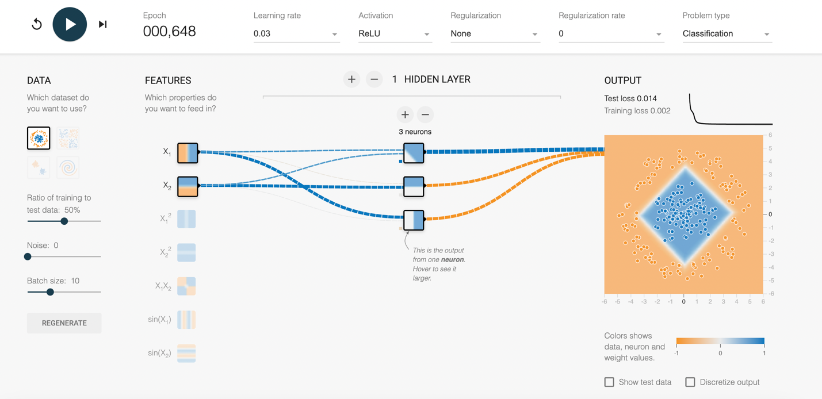

Picture 1

In the below picture (2), the activation function has been changed to the Tanh function. This function has the same learning rate 0.03 and 1 hidden layer with 3 neurons. As we can see that the neuron weights are heavy on all of the hidden neurons. After combining the results of the model, its output is almost giving the same test and training loss.

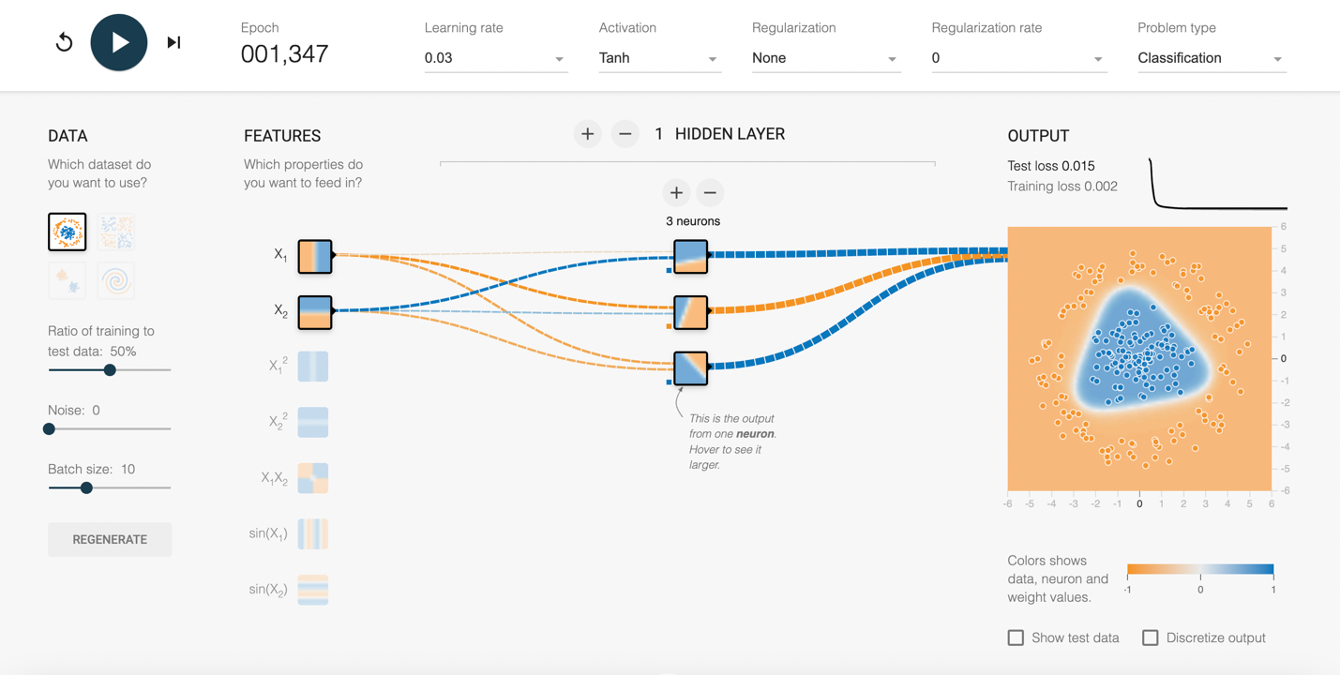

Picture 2

The next experiment was with the sigmoid function. With the sigmoid function, it looks like it is taking more cycles through the training data for the model to converge. In the end, it is still able to solve the problem in the same environment used by the other two function ReLU and Tanh.

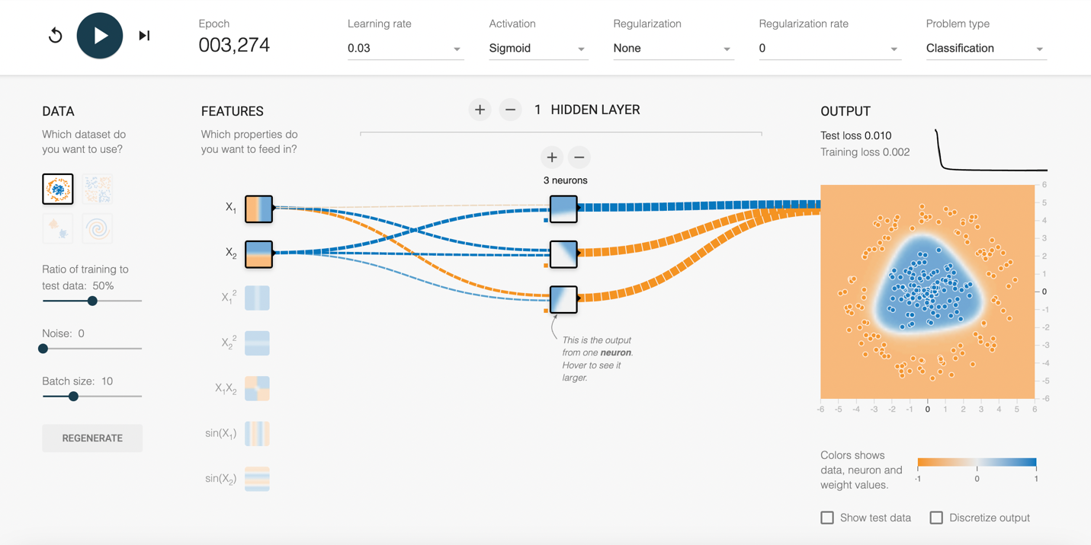

Picture 3

Lastly, we tested the model with a linear function. As you can see in the picture, this model does not converge, and the test and training losses are extremely high compared to the other functions. The output picture does not show strong orange and blue colors, also signifying that the model is not able to predict the solution with test data. It seems that the linear function works where is a a linear separation between the choices, which is not the case with the below data.

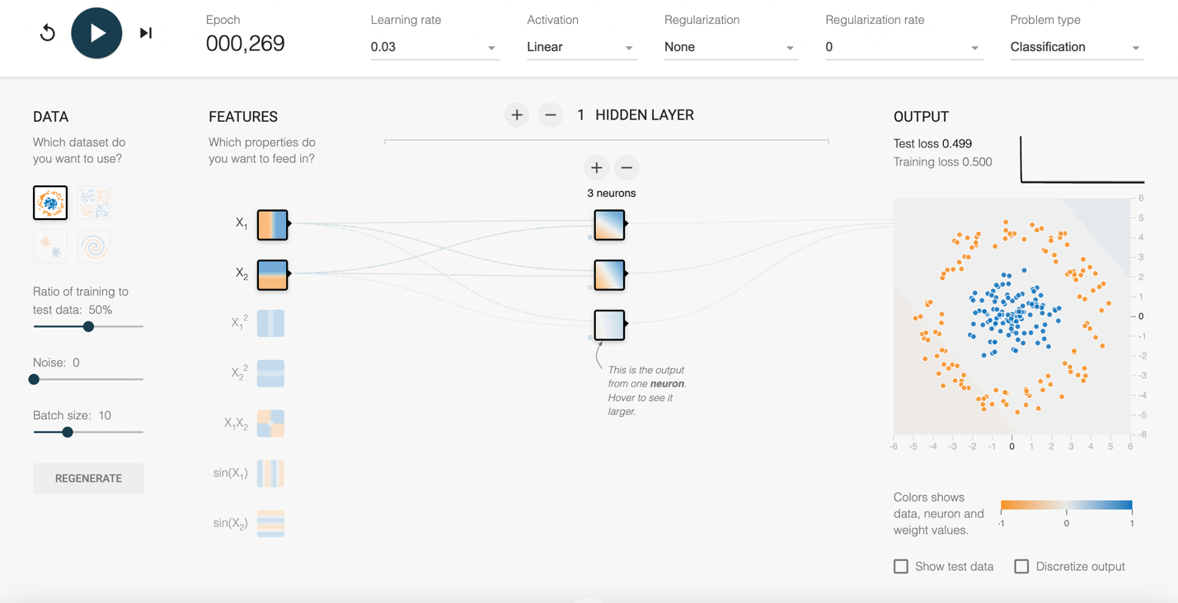

Picture 4

**Task 2 - Hidden Layer Neurons:**

Now, we will be changing the hidden layers and number of neurons with different functions and observing how it affects the network's performance. Neurons and hidden layers play crucial roles in a neural network.

**Neurons**: These are the basic units of a neural network, like brain cells. Each neuron receives input, processes it through a weighted sum, applies an activation function, and then passes the output to the next layer.

**Hidden Layers**: These are the layers between the input and output layers. They consist of multiple neurons and are responsible for transforming and processing the input data. Hidden layers enable the network to learn complex patterns and representations by adding non-linearity and depth.

Together, neurons and hidden layers allow a neural network to learn and generalize from data, making it capable of solving a wide range of tasks, from simple classifications to complex pattern recognitions.

So here in the below picture, we have added two more hidden layers and the learning rate is kept the same and the activation function is ReLU. In this example, the model is not converging. We think the reason is because of the problem of dying ReLU that is possible with using this activation function. This could be possible for a few different reasons, including potentially with the initial bias and weights as well as the possibility of large negative biases causing the activation function to go to zero and rendering that neuron inactive. When we refreshed the tensorflow model with the same parameters, the next time around it did converge. This made us feel that our original conclusion of the dying ReLU was correct.

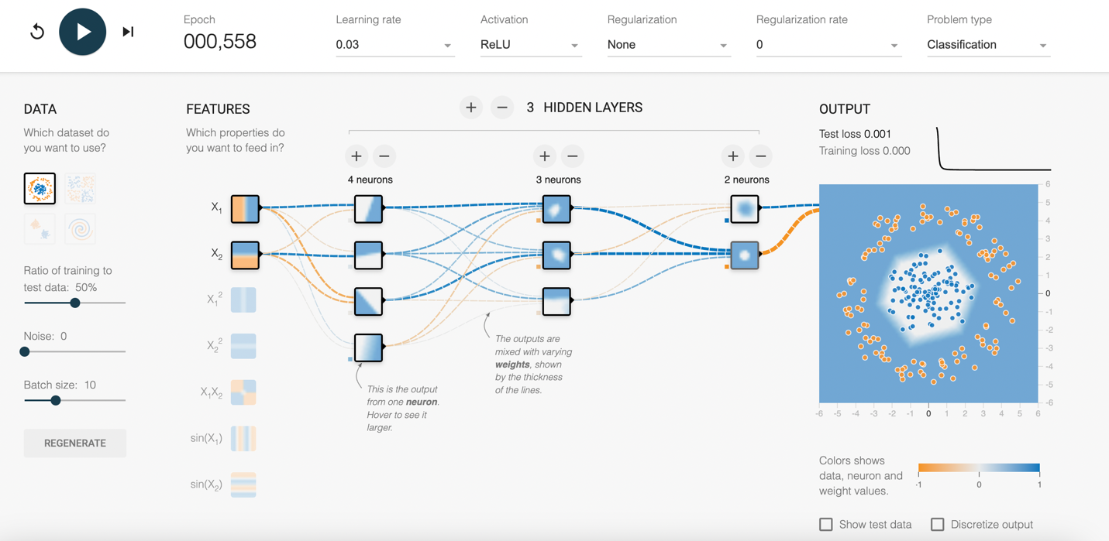

Picture 5

When we changed the number of neurons in the hidden layer, it looks like the model still converges. With simple data, it seems that adding neurons or hidden layers does not have a large impact in the model converging. In some of the more complex cases where we have added noise or have used more complex data, we can see that the test and training loss is lower in comparison. So the conclusion we came to was that adding neurons or hidden layers enables the model to work with more complex data. One of the downsides of a more complex model is that it requires more time to run the model. The first two pictures below show the effect of adding more neurons to the model. In this case, the difference is not that big, although we can see a slight drop in the test loss. (picture 6(a) and (b))

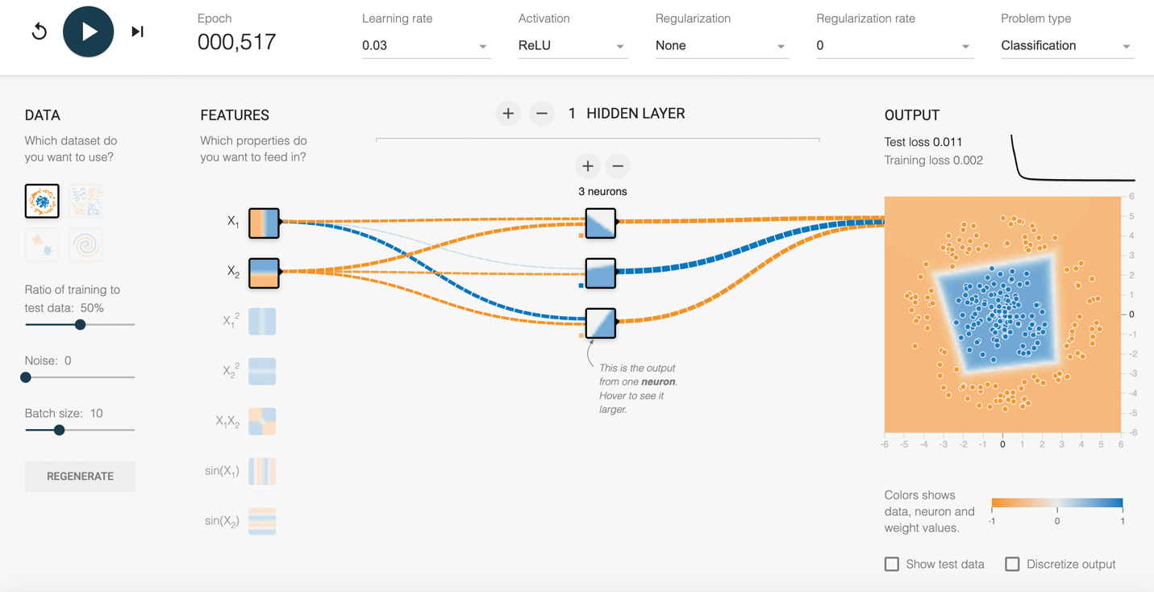

Picture 6 (a)

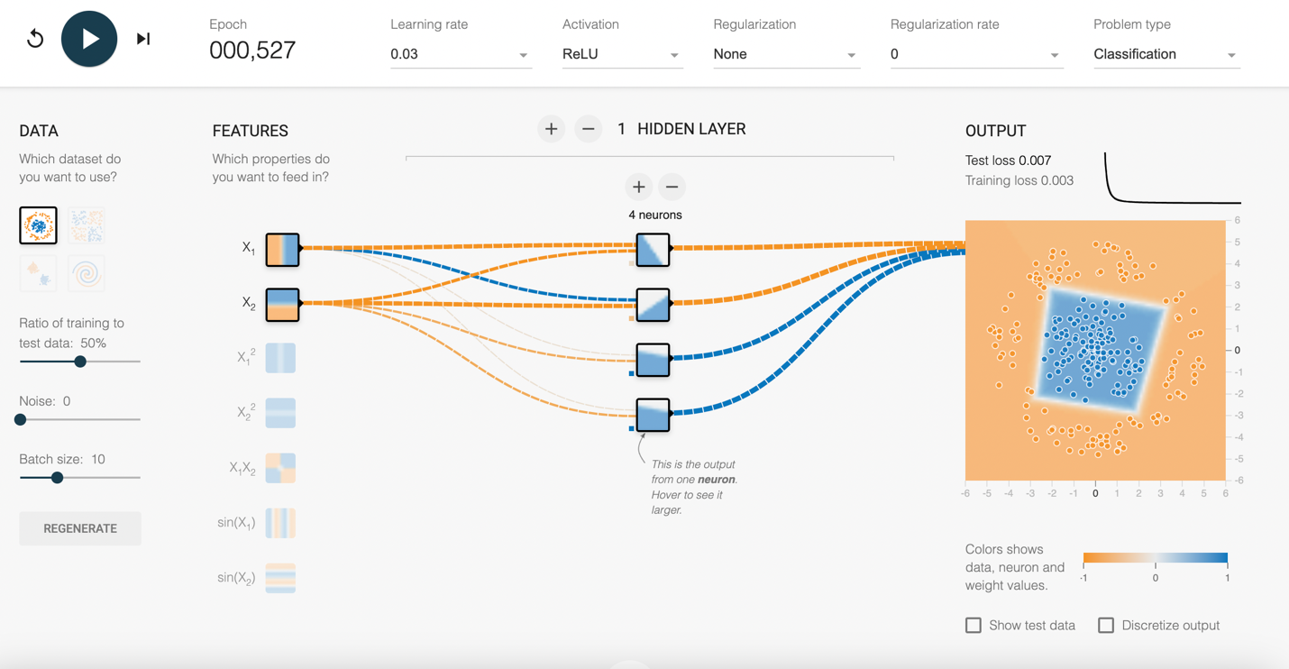

Picture 6 (b)

When we added two more hidden layers, it improved the model capacity, model flexibility and allows the network to build hierarchical representations. We noticed that now the test and training losses are almost negligible and can see an even better fit of the model to the test data. We also noted that adding more neurons or hidden layers had the potential to increase overfitting and potentially not work as well on the real data.

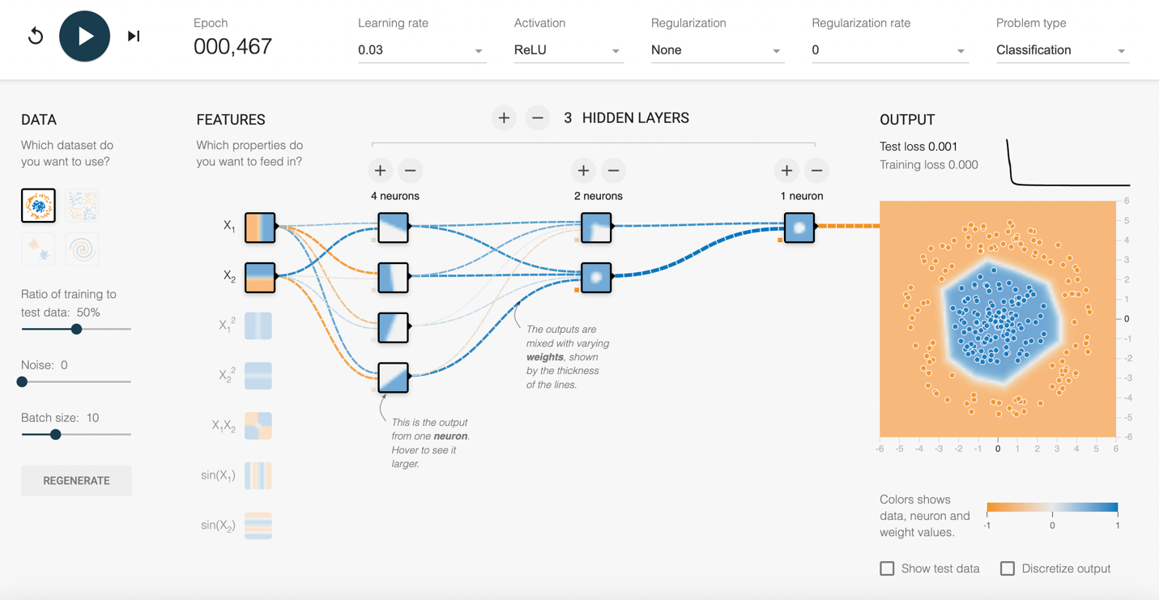

Picture 7

**Task 2 - Learning rate**

The learning rate is a hyperparameter that controls the size of the steps the model takes when updating its weights during training. It significantly impacts the training process, as too high of a rate can cause the model to converge too quickly to a suboptimal solution, while too low of a rate can make the training process slow and potentially get stuck.

After increasing the learning rate to 10, it explodes the gradient problem where it completely goes to infinity and can’t even solve the problem anymore. So here you can see if the learning rate is too high, we cannot see the solution and it only fluctuating and doesn’t produce a meaningful solution. And if we go to a learning rate which is too slow, it will produce the solution eventually, but it could take a really long time. In the picture with the low learning rate, you can see that the test loss and training loss are still high even after running around 500 cycles of the data.

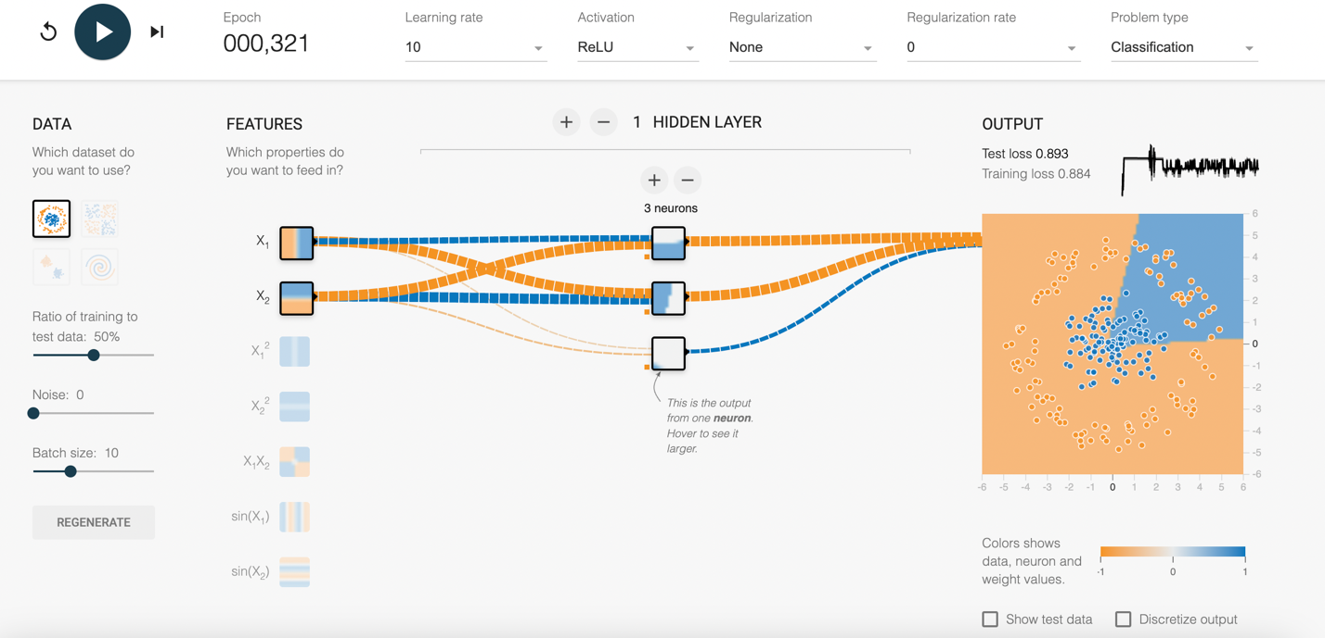

Picture 8 - Learning rate is too high (10)

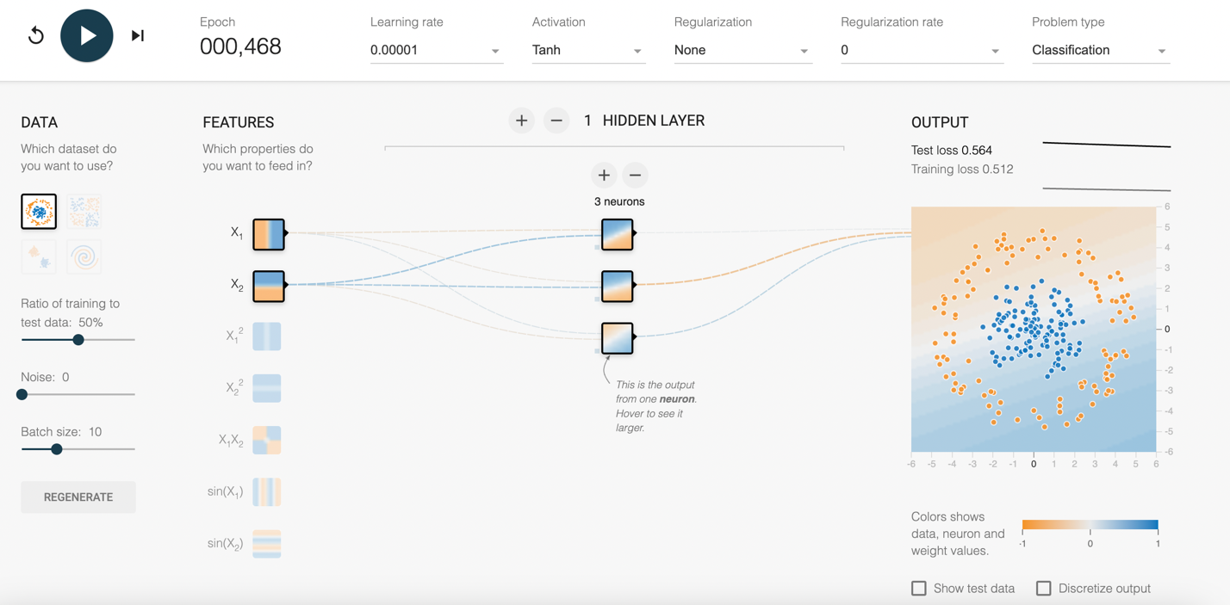

Picture 9- Learning rate is too low (0.00001)

**Task 4 - Data Noise**

Data noise is like random errors or irrelevant information in your dataset that don't reflect the real patterns. In neural networks, this noise can mess up the training by making the model learn these random bits instead of the true patterns, which means it won't perform well on new, unseen data.

Let’s add some noise to the problem to see what happens. We will be using the same pattern that we have using above. We can see outliers in the convergence of the model for both the blue and orange data points as we start to increase the noise.

Here we are adding the pictures of the gradually increasing noise in all the problems. By changing the noise level, we see its impact on training neural networks. With little to no noise, the neural network can easily learn the true patterns in the data, leading to high accuracy on both training and test data. As we increase the noise, the data points are more scattered and less representative of the true underlying patterns. This makes it harder for the neural network to distinguish between noise and the actual data patterns. The noise is causing overfitting in pictures 11and 12, where the model learns the noise, or underfitting, where it misses the actual patterns. The other problem is the higher loss in test and training data in all the tests, which means that the accuracy level is lower as you increase the noise. Also, we saw more fluctuation in the neural network as it went through the cycles of data with higher noise. This could potentially cause it to not converge properly or get stuck in a solution that is not the best for this data.

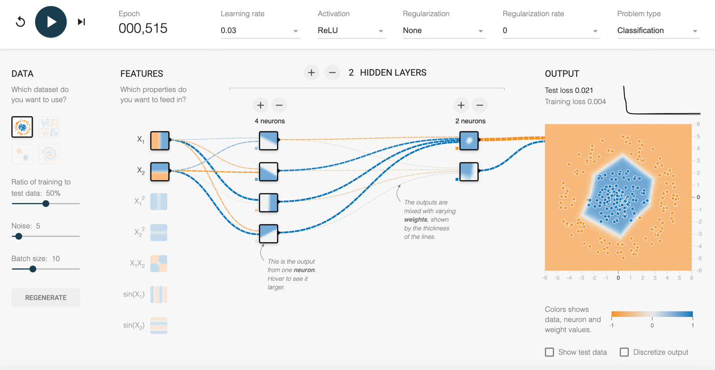

Picture 10

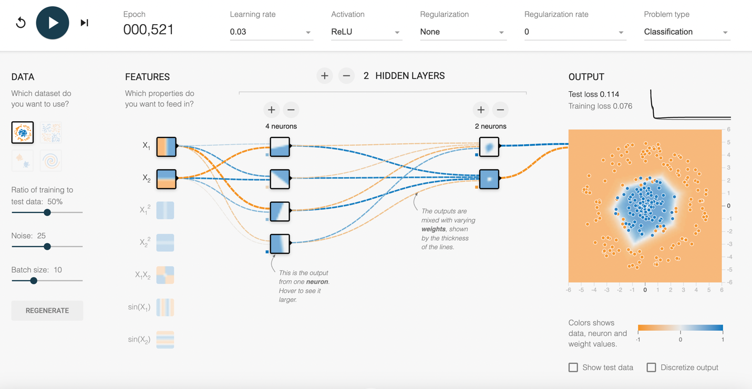

Picture 11

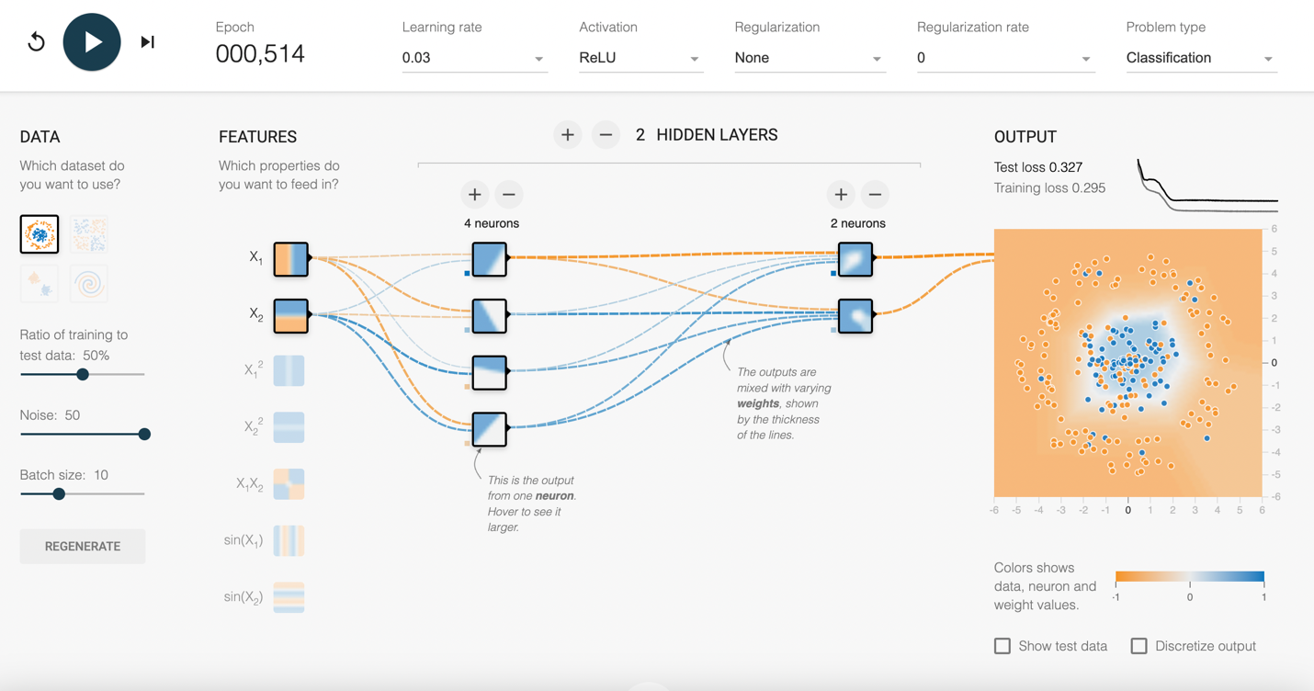

Picture 12

**Task 5 - Dataset Exploration:**

In TensorFlow Playground, here are the available datasets and an analysis of how the network typically performs on each:

First dataset is a circle and consists of points arranged in concentric circles. Adding more neurons and hidden layers can help the network to solve the problem easily. Also, using non-linear activation functions like ReLU or Tanh helps in learning the pattern effectively.

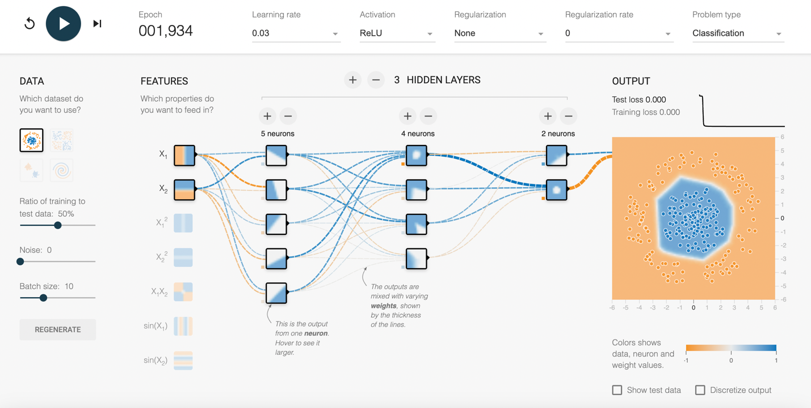

Picture 13

The second one is exclusive dataset which we called Exclusive OR. It provides points in opposite corners of a grid. The Exclusive OR pattern can't be separated with a straight line, so it's a classic test for neural networks. To get it right, you need at least one hidden layer in your network, which shows why non-linearity is important.

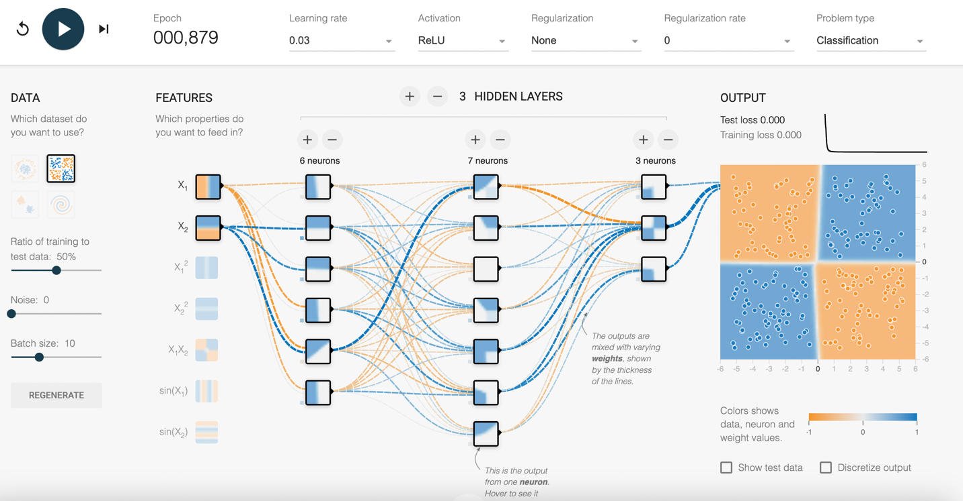

Picture 14

The third dataset is Gaussian which is grouped into two Gaussian-distributed clusters. The Gaussian neural networks can usually pick up this pattern easily, even with a simple setup. The dividing line between the two clusters is often straight or just slightly curved.

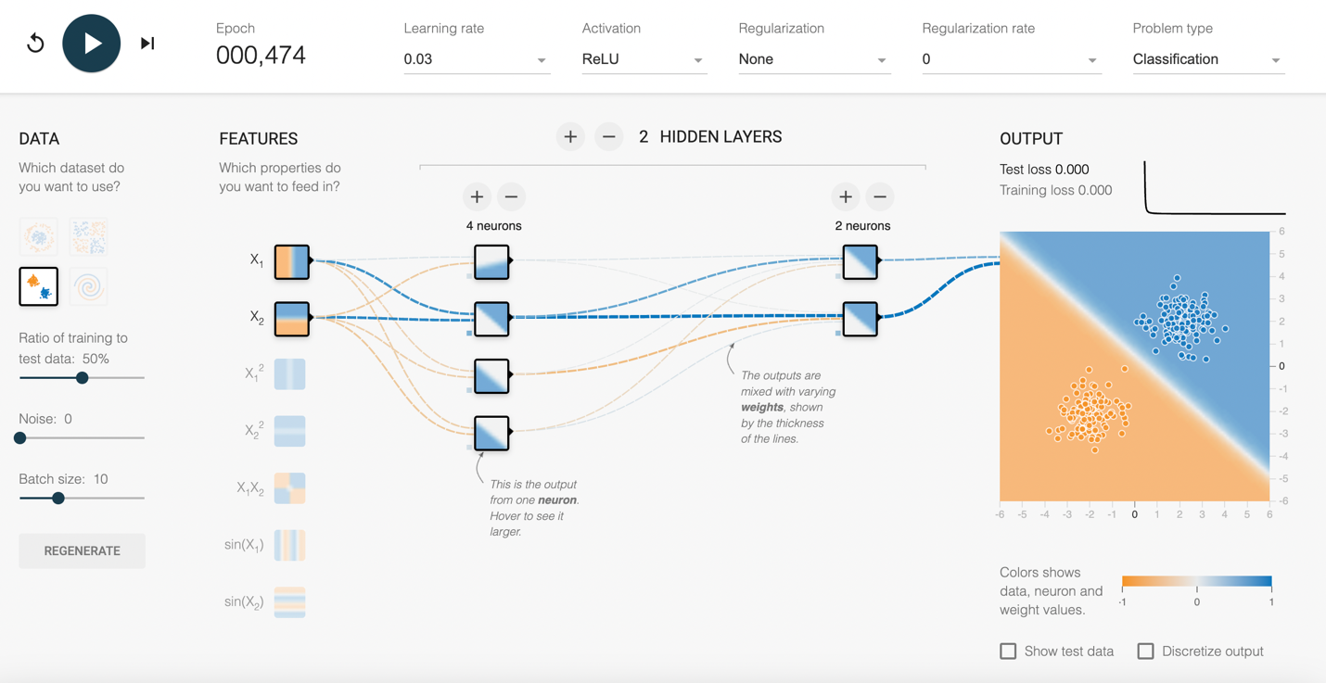

Picture 15

This is the last spiral dataset consists of two intertwined spirals. This is a complex dataset. It needs a complex network with multiple hidden layers and neurons to accurately classify the data points. Networks must figure out non-linear decision boundaries, which can be tricky. It often means you need to carefully adjust settings like the learning rate, number of neurons, and number of hidden layers.

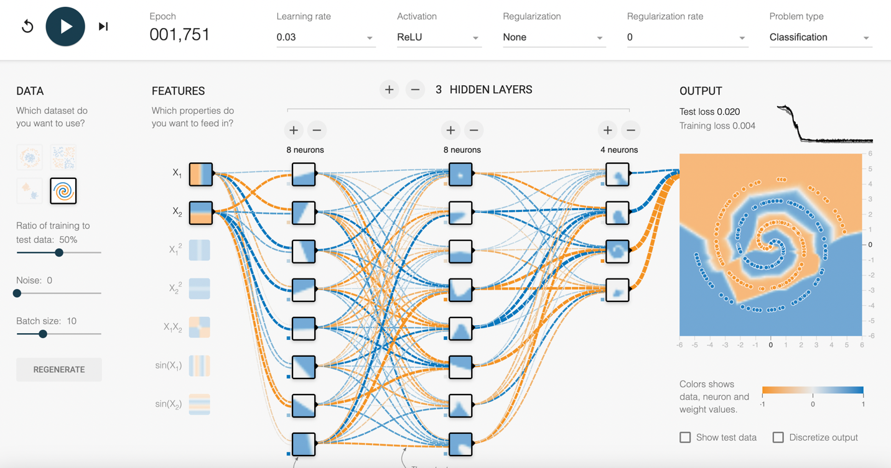

Picture 16

Selecting the right dataset is critical in neural network training. It directly impacts the model's performance, generalization capabilities, and suitability for the intended task. If there is not enough training data available for the model, it may not converge to the right patterns and that may result in a higher test loss because the data is not representative.

1. **Detailed observations and explanations for the effects of parameter changes:**

In TensorFlow, the activation function changes how neurons handle and learn from data. More neurons can make things complex and risk overfitting the data. The learning rates dictate how quickly or slowly a model adjusts weights during training. Learning rate can have a big impact on how quickly a solution can be found. If the learning rate is too fast, you can increase fluctuation and potentially miss the solution completely. Data noise can degrade accuracy and robustness, and and potentially cause overfitting or underfitting. This can impact the results of the test data. Dataset quality and diversity profoundly influence the network's ability to generalize and perform well on unseen data.

1. **A discussion of the practical implications of your findings:**

In real-world scenarios, adjusting parameters like activation functions, neuron counts, learning rates, handling data noise, and selecting appropriate datasets can optimize neural networks for specific tasks, enhancing accuracy, efficiency, and robustness to ensure reliable performance across diverse applications.

Knowing stuff like activation types, how many neurons to use, how fast it learns, dealing with noisy data, and picking the right datasets is super important in making neural networks work well. It's all about tweaking things just right so they can be accurate, tough, and efficient in all sorts of real-life jobs. In real world applications, the data gathering and using that to determine the training data is extremely important. This can make the solution accurate, precise, and useful for using it on test data.

In this hands-on journey, we have really gotten a feel for how neural networks mimic how we learn and make decisions. Experimenting with parameters like activation types, neuron numbers, and learning speeds showed us how it can change how well our models work. Dealing with noisy data and picking the right datasets also taught us that prepping the data right is key to making these networks smart and reliable in real-world tasks. This was our first stab at working with neural networks so that was a large learning curve. This required us to watch a lot of videos and do a lot of research before we could understand all the different parameters.

Some challenges we found in our whole testing. Adding layers and neurons were giving us different sets of results. At one time we got a result with only positive data and the model did not converge. This was likely due to a dying ReLU. One challenge we faced was dealing with overfitting when using too many neurons, especially with high data noise. We overcame this by experimenting with fewer neurons and reducing the number layers to improve the model's generalization to new data. We also struggled with converging on a model for the spiral data. This eventually worked with ReLU, but it required many hidden layers.

Reference - <https://playground.tensorflow.org/>

Lecture ppt

Chat GPT